Series and Parallel Circuits

Materials
Each group will have the following materials:

- 2, 1.5 Volt Batteries
- 2 to 3, Small Light bulbs/Sockets
- 4 to 6, Insulated wires with alligator clips on each end
- 1, Ammeter (optional)

Safety Consideration: The light bulbs and some other components which form a circuit can become hot.

Connection to Curriculum
S1-3-13 Construct electric circuits using schematic diagrams.
Include series, parallel.

Misconceptions

Many people, both students and adults have no idea how circuits and currents work. Students who are taught the subject and adults who have taken twelfth grade physics still carry incorrect ideas about the subject or will blatantly admit that they do not know anything about circuits and currents.
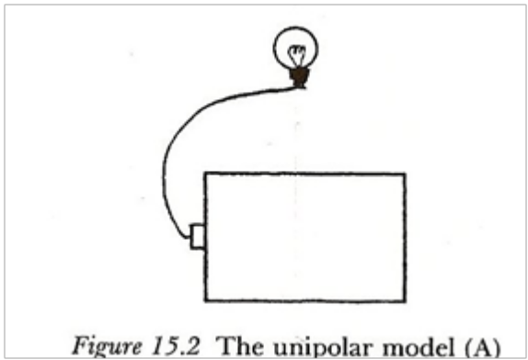
Most students and adults tend to understand that this unipolar model cannot possibly work. But when it comes to understanding current, people hold interesting ideas like clashing currents, or currents lessening or being consumed in a circuit.
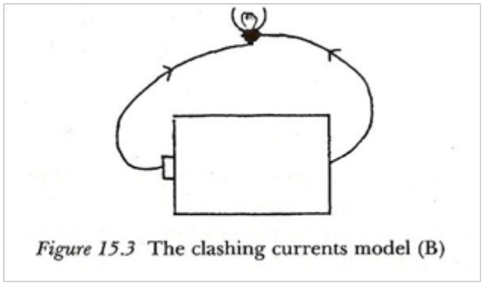
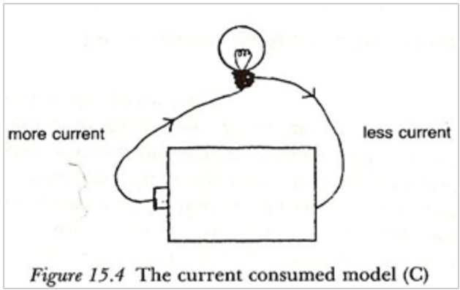
Figure 1: Taken from Driver, 1994.
Another preconceived notion is that if there is a resistor before a lamp, the resistor will dim the lamp in a circuit, but if the resistor is after the lamp then it will have no effect on the intensity of the light. Again, this shows that the students do not understand that current in a circuit is a flow of charge that is conserved. It remains the same and there is no difference when the current enters or leaves. In other words, it is not lost or gained. When teaching circuits, preconceived notions about currents, voltage, resistance, and electrical energy should have already been addressed in the start of the electricity unit, but often, as the statistics show, it is not addressed, and students carry their misconceptions further.

Experiential
Begin by displaying and explaining the components of a schematic diagram as it relates to the materials that will be used. Indicate what represents the battery, the resistance or in this case the light bulb, and the wires that connect the battery to the light bulb. Have the students build a simple circuit consisting of batteries, one light bulb, and two wires according to a schematic.

Schematic of Simple Circuit

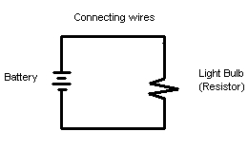
Most students should be able to accomplish making the circuit and causing the bulb to light. Quickly reviewing current, voltage, and resistance from the previous lessons and applying it to the context of the simple circuit can also be done at this time.

From here, activate the student's thinking by introducing a small scenario involving a tollway system along a highway (see Exercise 1 of Psychological Section). Examining the two different ways the tollbooths are set up will help the students begin to understand how to set up the two different types of circuits we will be looking at: series and parallel.

Next, show the schematic for a series circuit consisting of two light bulbs.

Schematic for a Series Circuit – 2 Light Bulbs
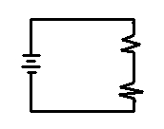
Have the students build the circuit with three questions in mind:
- How does adding more light bulbs (more resistance) affect the overall current of the series circuit?
- How does adding more light bulbs affect the overall resistance of the series circuit?
- What happens when one of the light bulbs is removed from the series circuit?
To answer the first two questions have the students make and record observations about the relative brightness of the bulb when there is one bulb in the circuit, then two, and then three. They should notice that the adding of more light bulbs causes the brightness of the bulbs to decrease. This indicates a decrease in the overall current caused by an increase in the overall resistance. The third question can be answered by unscrewing or disconnecting one of the light bulbs in the circuit. This will cause the other light bulb to go out which the students can observe and record.

Next, show the schematic for a parallel circuit consisting of two light bulbs.

Schematic for a Parallel Circuit – 2 Light Bulbs

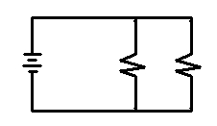
Have the students build the circuit, keeping in mind the same three questions for the series circuit except in relation to the parallel circuit. Have the students make and record their observations to test their answers to the three questions. The students should notice no change in the brightness of the bulbs as more are added in parallel. This might cause students to think that no change in either overall resistance or overall current occurred. To make the changes to the overall current and resistance more evident, either an ammeter or indicator bulb can be added to the circuit. The students could connect another light bulb which would act as the indicator bulb between the battery and the point where the connections branch off. The students would find that as more light bulbs were added in parallel, the indicator bulb would become brighter. This would imply that the overall current was increasing and the overall resistance was decreasing. Having the students use an ammeter in place of the indicator bulb to measure the current would also verify this.

Psychological

Prepared are two additional exercises: one to get students thinking about the differences in series and parallel circuits and to help explain the causes for the changes in overall current and resistance of each circuit, and one to address the concept of current.

Exercise 1:
The first exercise will be used as an activating strategy. Students will be introduced to the following scenario:

Do to the poor highway road conditions in Manitoba you have been contracted by the provincial government to set up a highway toll booth on the TransCanada Highway. The booth is to be stationed just east of Brandon, Manitoba, and for only the westbound traffic. Travellers heading westbound towards Brandon will have to pay five dollars at the toll booth. It is a two lane highway heading westbound, and the government has given you enough funding for two toll booths.
Your team has come up with the following two designs: How will this affect traffic flow? Which design would be a better choice?
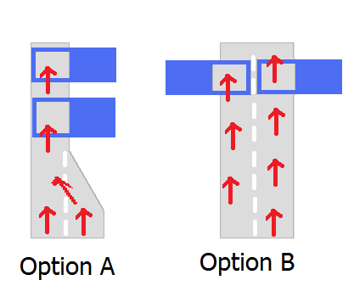
Figure 2

Students will be asked to discuss the benefits and the setbacks of the designs and decide which option would be best suited for the toll booth.

After the students have gone through constructing the series and parallel circuits, we come back to the tollbooth analogy to help explain the answers to the first two of the three questions. Ask the students which of the tollbooth designs best resembles series circuits or which one resembles parallel circuits. Most will come to the conclusion that design A represented a series circuit while design B represented a parallel circuit. Their reasoning behind this would be based on comparing the tollbooths to resistors and comparing the possible pathways between the tollbooths. Tell the students that the tollbooths are indeed like resistors and the cars are the charges flowing on the pathways available. By adding more tollbooths in a series so that they are all connected by a single pathway, the tollbooths effectively slow down the flow of cars because the cars would have to pass through every tollbooth on the path. This corresponds with our observation that adding more resistances to a circuit in series causes a decrease in current.

In examining design B we see that by placing the tollbooths in parallel, the cars have two different pathways they can take and will only have to pass through one of the tollbooths. By adding more tollbooths in parallel, the cars will have more pathways and the overall flow of cars will increase. This corresponds with our observation that adding more resistances in parallel actually increased current.

Care must be taken with this analogy so that students do not acquire the misconception that the current changes before and after passing through resistances in series. This analogy is simply to demonstrate how increasing the resistance can cause changes in the overall or total current for a circuit in different ways.

Exercise 2:
To help students understand series and parallel circuits better, they will be acting out the roll of charges in the current. In a train like fashion, they will link together around the classroom. Two chairs will serve as lamps which the teachers must touch to pass, and the teacher’s desk will be the battery. They will move each other forward to understand how the current works.

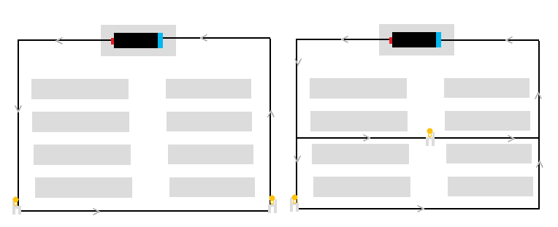
Series Circuit Parallel Circuit
Figure 3
Because students will be forming a continuous moving chain of current, they will better understand that once they touch the chair (go through the lamp) in series, the current will not lessen or be weakened before or after. Instead, students will see that they all continue to move at the same rate. The rate at which they collectively move is what changes depending on how much resistance is placed in their path. When the students move through a parallel circuit they will notice that after they split up to take the different paths, a lot more of them will be able to get back to the teachers desk for some interval of time compared to moving in a series.

To demonstrate what happens when a bulb is removed from the circuit, a chair can be removed. Assuming that each student has to touch a chair before moving on in the circuit, the removal of the chair in the series would cause a stop to all movement. If a chair were removed in the parallel circuit, the students would still have another pathway back to the desk. These results correspond with our observations and our answer for question 3 previously.

Theoretical

In the series circuit we found that adding resistance causes an increase in the overall resistance and a decrease in the overall flow of charge, current. The overall or total resistance is the sum of the individual resistances in the circuit. The overall resistance in the series circuit could then be represented symbolically as:

R_{T} = R₁ + R₂ + R₃ + …

In the circuit we made with two light bulbs, the overall or total resistance in the circuit would then equal the sum of the individual resistance of the two light bulbs.

We know by Ohm’s law that current is inversely proportional to resistance, so an increase in resistance would correspond to a decrease in current.

In the parallel circuit we found that adding resistance causes a decrease in the overall resistance and an increase in the overall current. In the parallel circuit, the sum of the current flowing through each of the branches of the circuit is equal to the overall or total current:

I_{T} = I₁ + I₂ + I₃ + …

The overall or total resistance however has the following relationship:

1/R_{T} = 1/R₁ + 1/R₂ + R₃ + …

In the parallel circuit we constructed we had two branches. The total current would then be the sum of the current flowing through each branch. The total resistance would be equal to the sum of the inverses of the resistances of the two bulbs. The relationship shows that as more resistances are added, the total resistance will decrease.

Work Cited / References

Driver, Rosalind. Children’s Ideas in Science. Taylor and Francis, 1985.

Driver, Rosalind. Making Sense of Secondary Science: Research into Children’s Ideas.
Taylor and Francis, 1994.

The Physics Classroom. Two Types of Connections.
http://www.glenbrook.k12.il.us/gbssci/phys/Class/circuits/u9l4b.html

The Physics Classroom. Series Circuits.
http://www.glenbrook.k12.il.us/gbssci/phys/Class/circuits/u9l4c.html

The Physics Classroom. Parallel Circuits.
http://www.glenbrook.k12.il.us/gbssci/phys/Class/circuits/u9l4d.html

Appendix A

Series Circuits

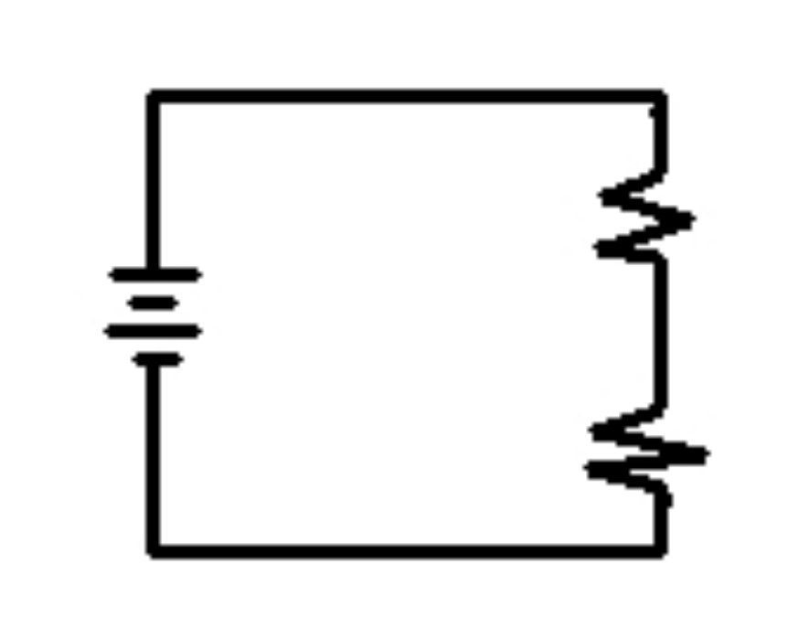

- How does adding more light bulbs (more resistance) affect the overall current of the series circuit?
- How does adding more light bulbs affect the overall resistance of the series circuit?
- What happens when one of the light bulbs is removed from the series circuit?

Appendix B

Parallel Circuits

- How does adding more light bulbs (more resistance) affect the overall current of the parallel circuit?
- How does adding more light bulbs affect the overall resistance of the parallel circuit?
- What happens when one of the light bulbs is removed from the parallel circuit?

Appendix C

Do to the poor highway road conditions in Manitoba you have been contracted by the provincial government to set up a highway tollbooth on the TransCanada Highway. The booth is to be stationed just east of Brandon, Manitoba, and for only the westbound traffic. Travellers heading westbound towards Brandon will have to pay five dollars at the tollbooth. It is a two lane highway heading westbound, and the government has given you enough funding for two tollbooths.
Your team has come up with the following two designs. How will this affect traffic flow? Which one will you choose?

